GloVe(Global Vectors for Word Representation):
GloVe (Global Vectors for Word Representation) is an unsupervised learning algorithm that generates dense word embeddings by analyzing co-occurrence patterns in a large text corpus, capturing semantic relationships between words.
It converts words into vectors.
- Uses a word co-occurrence matrix to learn relationships between words
- Combines global statistical information (LSA) with local context-based learning (like Word2Vec)
- Optimizes embeddings so the dot product approximates Pointwise Mutual Information (PMI)
- Captures both semantic and syntactic relationships

GloVe provides pre-trained dense vectors learned from large corpora (e.g., 6 billion tokens), with embeddings available for a large vocabulary of unique words. These embeddings represent words as numerical vectors that capture semantic relationships.
- Contains vectors for a large vocabulary, including words and common symbols
- Can be directly downloaded and used in NLP applications
- Available in different dimensions such as 50d, 100d, 200d and 300d

Working of Glove:
- Preprocess the text:
First , we have to split the text into individual word (tokenization) so that we can work with them.
Eg. “The peon is ringing the bell”
[“The”, “peon”, “is”, “ringing”, “the”, “bell”]

- Create Vocabulary:
After tokenization, we create a list of all unique words in the text and count how often each word occurs.
Eg. Vocabulary with word frequencies
{‘The’:2, ‘peon’:1, ‘is’:1, ‘ringing’:1, ‘the’:1, ‘bell’:1}

- Build a Co-Occurrence matrix:
We have to build a co-occurrence matrix to count how often each word appears near other words in given context.
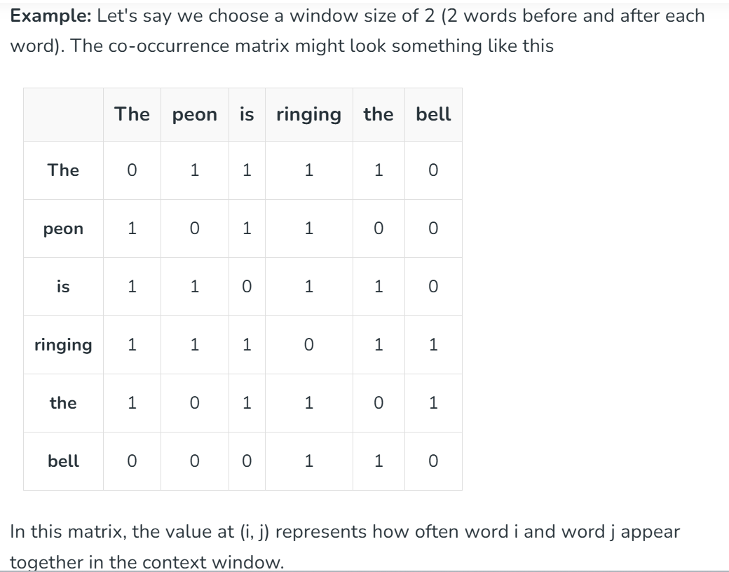
- Performing Dot Product:
The aim is to learn word vectors such that the dot products of two word vectors represents hoe often the words co-occur in the context. This will make sure that words that appear in similar context have similar vector representation.
Eg. "The" and "is" are frequently seen together, so their vectors will be close in the embedding space.
"peon" and "bell" don't co-occur much, so their vectors will be far apart.

- Training Word Vectors:
The model learns word embeddings by adjusting vectors based on how often words appear together. It aims to capture meaningful relationships between words using co-occurrence information.
Eg. "The" and "is" will have vector adjustments that make their dot product similar to their co-occurrence probability, ensuring their vectors are close to each other.
"peon" and "bell" will be adjusted to have distant vectors since their co-occurrence is low.

- Embedding Matrix:
After model trained, the model outputs an embedding matrix where each word is represented by a dense vector.
